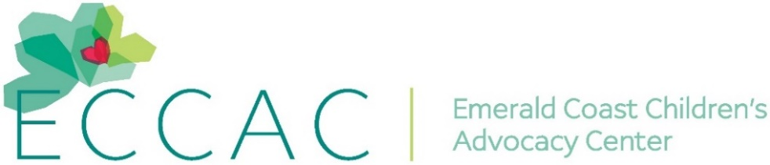
PR Contact:
Kay Phelan
Phelan & Lowry, Ltd.
850-376-1551
kayphelan@earthlink.net
FOR IMMEDIATE RELEASE

Special Walton Area Chamber Ribbon Cutting for the children
…Their 2025 Leadership Class partnered with
ECCAC’s Pierce Family Center to re-do the courtyard

DeFuniak Springs FL (May 9, 2025)…The 2025 Walton Leadership Class from the Walton Area Chamber of Commerce undertook a caring project for the Emerald Coast Children’s Advocacy Center’s (ECCAC) Pierce Family Center in DeFuniak Springs. The group raised over $10K to do updates and renovations to the Dugas Family Courtyard that has been in place since the Center’s opening in 2016. A ribbon cutting ceremony at the courtyard officially re-opened the courtyard.
The transformed outdoor courtyard updates included flowers, trees, games, decorative pavers, furniture and benches that will provide the staff, children and families somewhere to play, meet, hold cookouts and offer an enclosed area that is safe. Not only did the Leadership Class raise the funds to do this project, they also joined together to physically do the work.
ECCAC’s CEO, Julie Porterfield commented, “A huge thank you to the Walton Leadership Class members who made this meaningful project possible. We so appreciate their hard work, creativity and dedication in bringing this space to life. Our therapists can now conduct sessions outside and a space for kids to play.”
A program offered by the Walton Area Chamber, Leadership Walton is a unique and innovative approach for men and women who have achieved leadership positions in their fields and are likely to be tapped for greater community responsibility. These exceptional individuals strengthen their skills through experiential learning, team building, communication, time management and more,
ECCAC’s mission is to heal and prevent the trauma of childhood abuse and neglect by providing advocacy, child-friendly therapies, and a safe environment for kids to feel seen, heard, and understood. In 2024 alone, ECCAC served 1,440+ kids and 12,500+ students received Child Safety Matters prevention education in area schools. Though ECCAC doesn’t house children, they provide services to children and their families at no cost in their Okaloosa and Walton County Centers.

For further information about ECCAC, visit www.ECCAC.org. If abuse is suspected, report it by calling the anonymous Florida Abuse Hotline at 1-800-96-ABUSE.
# # #

…more…

Page Two
These photos attached to email:

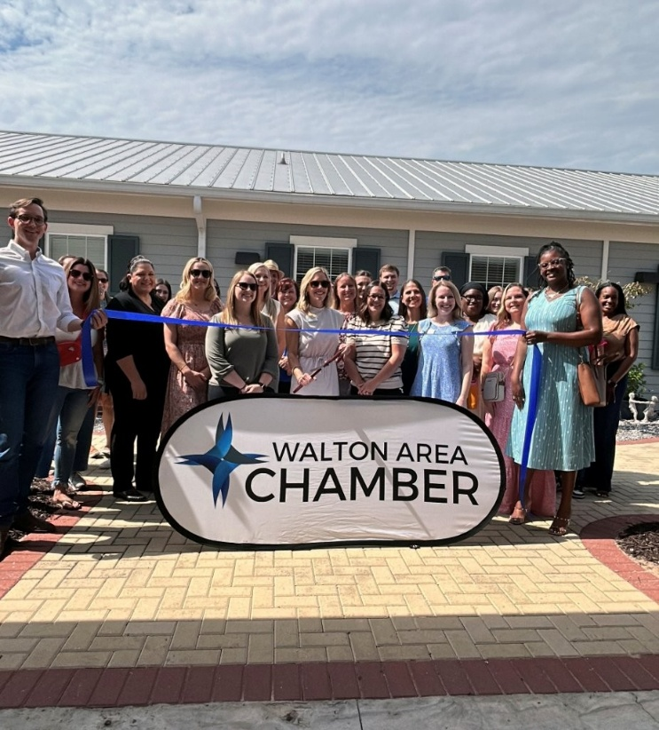
After their work to raise funds and re-do the now child-friendly Courtyard, the Walton Area
Chamber’s 2025 Walton Leadership Class did a ribbon cutting at ECCAC’s Pierce Family Center.

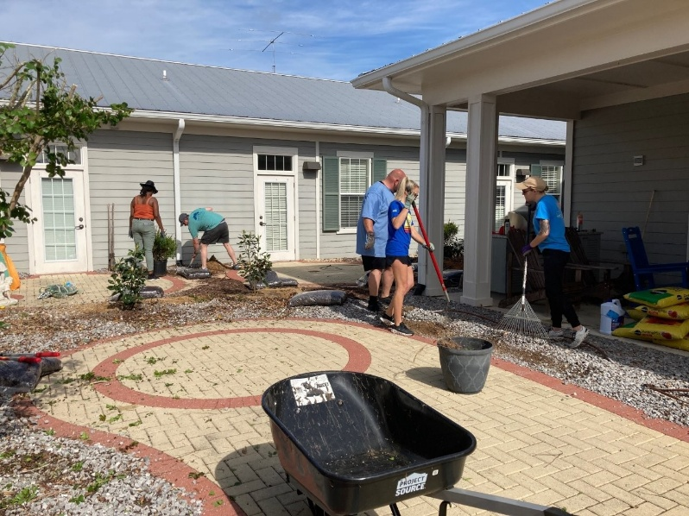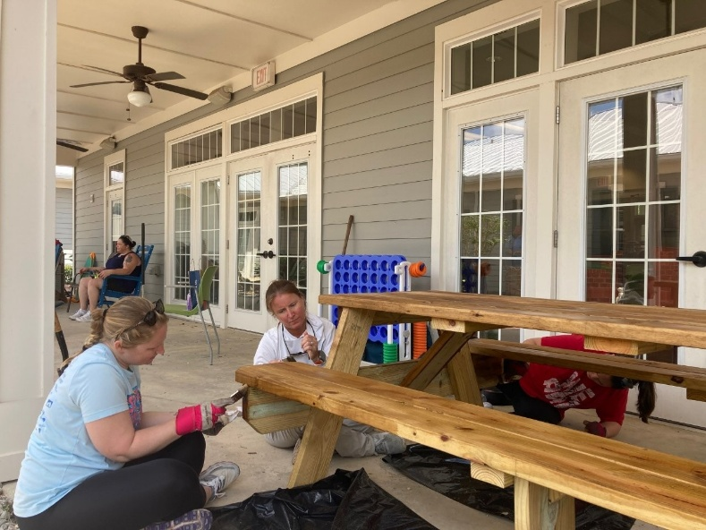
2025 Walton Leadership Class hard at work updating and renovating
ECCAC’s Courtyard in DeFuniak Springs.
END

