
PR Contact:
Kay Phelan
Phelan & Lowry, Ltd.
850-376-1551
kayphelan@earthlink.net
FOR IMMEDIATE RELEASE

ECCAC launches Back-to-School Supplies Drive
From July 1 through August 4

Niceville and DeFuniak Springs, FL (June 30, 2025)…The Emerald Coast Children’s Advocacy Centers (ECCAC) in Niceville and DeFuniak Springs have launched their annual Back-to-School Supplies Drive in Okaloosa and Walton Counties. For the third year in a row, Intuitive Research and Technology in Niceville has donated not only a $1,000 donation towards supplies, but also 100 back packs.

“We are asking people to support our community by helping ECCAC fill the back packs with donations of back-to-school supplies for the upcoming new school year,” commented ECCAC CEO Julie Porterfield. “We have many drop off locations for the supplies at our Centers, as well as area businesses and churches in Destin, Niceville, Ft. Walton Beach, Crestview and DeFuniak Springs. We also need volunteers to help us sort and distribute the supplies to ensure they will reach the students who need it the most to thrive in the classroom.”

With a focus on school supplies such as pencils, pens, crayons, loose leaf paper, and spiral notebooks, the Drive will run from July 1 through August 4. ECCAC has also created an Amazon Wishlist showing the most needed items. Supplies can be shipped directly to the Centers, or dropped off in person to the Centers or designated community partner drop off locations. Visit https://eccac.org/back-to-school-campaign/ for more information, a link to the Amazon Wishlist page, drop off locations, or to make a donation. All donated items will be distributed to local schools and community centers before the start of the 2025-2026 school year.

ECCAC’s mission is to heal and prevent the trauma of childhood abuse and neglect by providing advocacy, child-friendly therapies, and a safe environment for kids to feel seen, heard, and understood. Last year alone, ECCAC assisted 1,585 kids and 17,480 students received Safety Matters prevention education in area schools. This year, ECCAC’s prevention team will visit 32 schools within the Okaloosa and Walton County School Districts. Last year, ECCAC added a new program that is targeted to help families, CARES. It stands for Community Awareness, Advocacy, Resources, Education and Support. Though ECCAC does not house children, they provide services to children and their families at no cost in their two Centers.

For more information, visit www.eccac.org. To volunteer, contact Kate McDougall-Mason, 530-392-0802, or kate@eccac.org. If abuse is suspected, report it by calling the anonymous Florida Abuse Hotline at 1-800-96-ABUSE.

Page Two
ECCAC-Back-to-School Supplies Drive

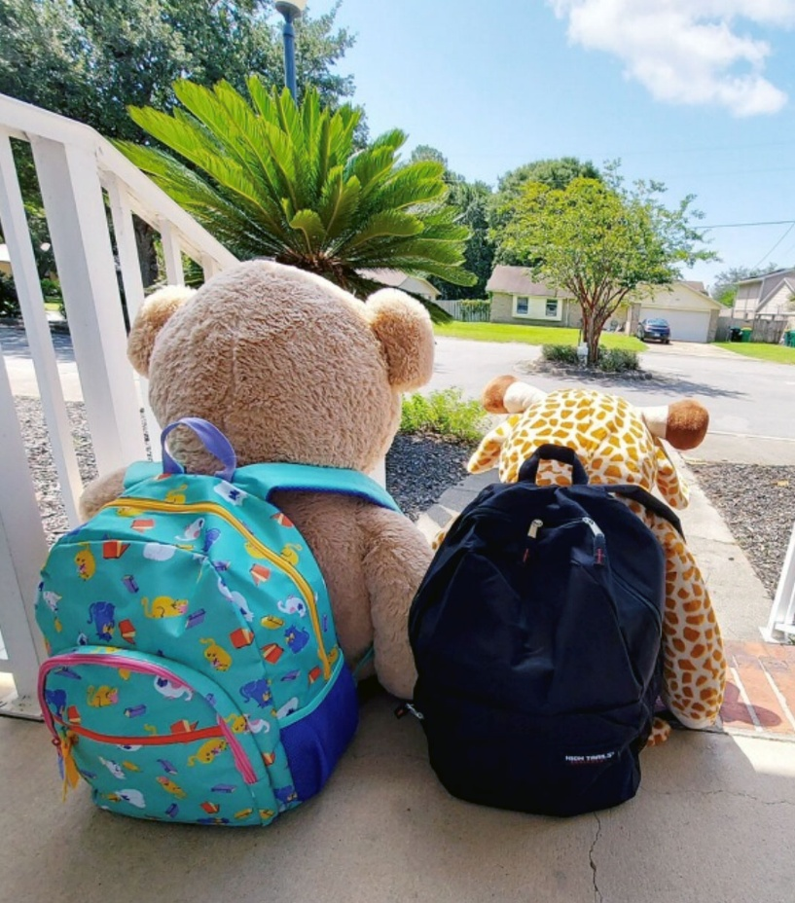

ECCAC asking community to help support area children by
donating back to school supplies July 1 to August 4.

