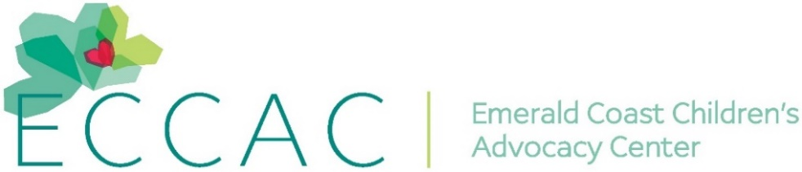
PR Contact:
Kay Phelan
Phelan & Lowry, Ltd.
850-376-1551
kayphelan@earthlink.net
FOR IMMEDIATE RELEASE

ECCAC recognizes National Child Abuse Prevention month in April
…Walton and Okaloosa County Sheriffs sign official proclamations

Niceville and DeFuniak Springs FL (April 26, 2025)…The Emerald Coast Children’s Advocacy Center (ECCAC) just recognized National Child Abuse Prevention throughout the month of April. This recognized the importance of families and communities working together to prevent child abuse and neglect. Effective child abuse prevention programs succeed because of partnerships among families, social service agencies, schools, religious and civic organizations, law enforcement agencies and the business community. Prevention services and support developed by this collaboration can help parents, other caregivers, and communities protect children.
The National Children’s Alliance is the force behind 959 Children’s Advocacy Centers throughout the United States. Last year, these Centers served 380,494 children at no cost. Locally, the Emerald Coast Children’s Advocacy Center (ECCAC), located in Walton and Okaloosa Counties, served 1,480 children in its intervention programs and 17,367 students in its prevention program in Okaloosa and Walton school districts.

“Our ECCAC team undertook a number of initiatives throughout April to bring attention to National Child Abuse Awareness Month,” commented ECCAC CEO, Julie Porterfield. “With the color blue representing the initiative, we lined our sidewalks with blue pinwheels and baloons. We also participated in Lauren’s Kids Walk with Florida Attorney General James Uthmeier in Niceville for a 10-mile trek as a part of their 1,500-mile journey across Florida. The walk was for Lauren’s Kids and the 42 million survivors of child abuse in America and for the children we see every day at our Centers. We’re already creating our strategic plan for next year.”

As well, to recognize National Child Abuse month, Niceville’s ECCAC hosted a proclamation signing ceremony with Okaloosa County Sheriff Eric Aden. In DeFuniak Springs, ECCAC also had a proclamation signing ceremony with Walton County Sheriff’s Office, Captain Dustin Cosson.

For over 25 years, ECCAC’s mission has been to prevent child abuse and neglect, protect children, and restore the lives and futures of impacted children. It’s important to note that 1 in 3 girls and 1 in 5 boys will be sexually abused before they finish high school. Child sexual abuse is 95% preventable through awareness and education, knowledge is power.

For further information about ECCAC, visit www.ECCAC.org. If abuse is suspected, report it by calling the anonymous Florida Abuse Hotline at 1-800-96-ABUSE.
# # #
…more…
Page Two
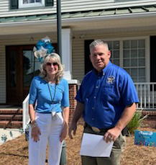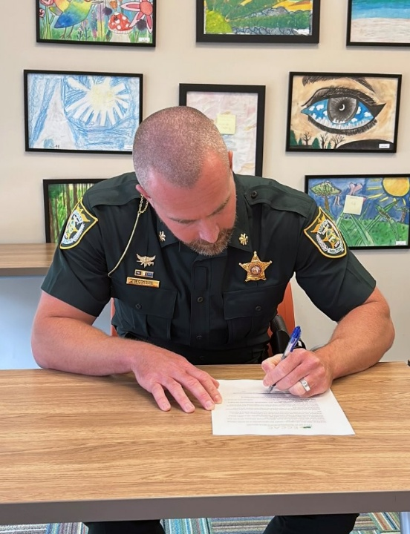
ECCAC CEO Julie Porterfield and Okaloosa WSCO Capt. Dustin Cosson signs proclamation
County Sheriff Eric Aden at Niceville Center. at ECCAC’s DeFuniak Springs Center.

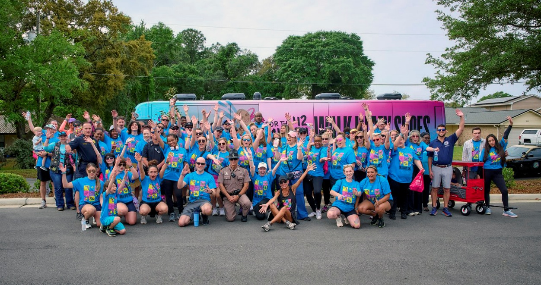
Accompanied by Florida Attorney General James Uthmeier,
ECCAC’s staff participated in the Lauren’s Kids Walk for a 10-mile walk in Niceville.

