**PR Contact:**

Kay Phelan

Phelan & Lowry, Ltd.

850-376-1551

[kayphelan@earthlink.net](mailto:kayphelan@earthlink.net)

FOR IMMEDIATE RELEASE

**Harley Davidson Owners Group #3605 hosts their**

**45th Annual Toys 4 Tots ride to benefit kids in need**

*Niceville FL (October 22, 2024)…*Rev up your engines for a cause, the holiday season is just around the corner. The Emerald Coast Harley Davidson Owner’s Group # 3605 are proudly hosting their 45th annual Toys 4 Tots ride and event on November 17. As in years past, children at the Emerald Coast Children’s Advocacy Center (ECCAC) and Children In Crisis (CIC) will benefit with toys and money donations.

Registration for the ride starts at 8:30am at Emerald Coast Harley Davidson, 788 Beal Parkway NW, in Fort Walton Beach. It’s not just for bikers, but Jeeps, Corvettes, sports bikes and cruisers can join in, too. Bring $10 per person, along with a new toy or gift card to donate, and ride over to the Mullett Festival grounds. Starting at 11am, enjoy an afternoon of fun with bike games, a best-decorated bike/auto contest, a car & truck show, a 50/50 drawing, DJ Anthony, delicious food trucks, and over 100 prizes.

ECCAC’s mission is to heal and prevent the trauma of childhood abuse and neglect by providing advocacy, child-friendly therapies, and a safe environment for kids to feel seen, heard, and understood. Though ECCAC doesn’t house children, they provide services to children and their families at no cost in their Okaloosa and Walton County centers. However, Children in Crisis does provide shelter in a nurturing environment, foster homes, and transitional living programs for children who have been removed from their homes.

For further information, visit [www.ECCAC.org/event](http://www.ECCAC.org/event) or contact Ana Michalzik at [ana@ECCAC.org](mailto:ana@ECCAC.org). You can also pre-register for the event online by visiting [www.childrenincrisisfl.harnessgiving.org/events](https://childrenincrisisfl.harnessgiving.org/events/2229)

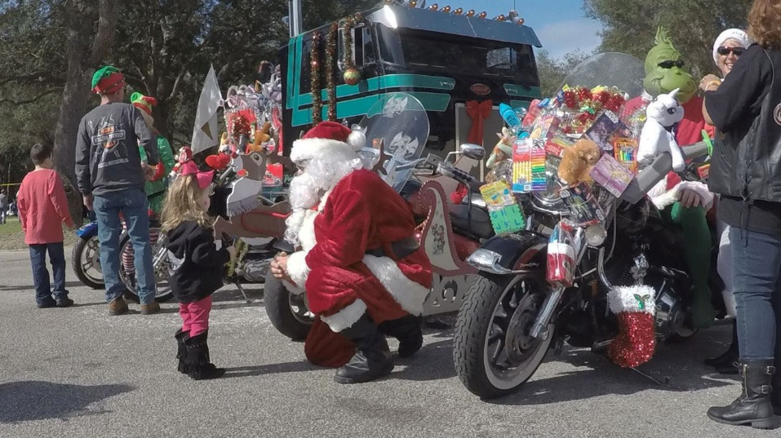

The 45th Annual Toys 4 Tots motorcycle ride from Ft. Walton Beach to

Niceville’s Mullet Festival site will be on November 17.