**PR Contact:**

Kay Phelan

Phelan & Lowry, Ltd.

850-376-1551

[kayphelan@earthlink.net](mailto:kayphelan@earthlink.net)

FOR IMMEDIATE RELEASE

**ECCAC recognizes 2025 Zeke Bratkowski Award winners**

*Niceville FL (March 14, 2025)* The Emerald Coast Children’s AdvocacyCenter (ECCAC) recognized two couples for their remarkable dedication to the community and children in need, Jim and Tammy Pierce and Mike and Valerie Thompson received the prestigious 5th Annual Zeke Bratkowski Award this year at ECCAC’s recent Gala.

The professional football quarterback, and later NFL coach, played for three NFL teams for 14 seasons. After his retirement, Zeke Bratkowski lived in Northwest Florida and was a major supporter and spokesperson for ECCAC before he passed away in 2019. He was also responsible for the beginning of ECCAC’s annual signature event, now in its 27th year, the Gala & Golf Weekend.

In the fall of 2014, Walton County residents, Jim and Tammy Pierce stepped forward at the groundbreaking of ECCAC’s second center in DeFuniak Springs with a generous $1 million donation. Subsequently, in honor of the Pierce’s, ECCAC named the facility The Pierce Family Children’s Advocacy Center. Since that time, they have continued with their support of ECCAC in many ways, including Tammy Pierce serving on ECCAC’s Board of Directors from 2015 to present, and serving as the Board President in 2018/2019.

Jim Pierce, a retired business executive, experienced a disruptive childhood first-hand, so he can relate to the needs of the children ECCAC serves. He commented, "We are incredibly honored to receive the Zeke Bratkowski Award alongside Valerie and Mike Thompson. Supporting the Emerald Coast Child Advocacy Center means giving children a voice, a safe place to heal, and hope for a brighter future. Every child deserves to feel safe and heard, and we are grateful to be part of an organization that works tirelessly to make that a reality."

The other couple being recognized for the Zeke Bratkowski Award, Mike and Valerie Thompson, are also residents of Walton County. As well, they also own a vineyard in the Russian River Valley area of California where they created Thompson 31Fifty winery. A long-time ECCAC supporter, Mike Thompson has served on ECCAC’s Board of Directors for 15 years, and he is still on their Board.

One of the Thompson’s greatest endeavors to support area children’s charities came about in 2007 when they began hosting a backyard barbeque party. It became the Chi Chi Miguel Throwdown in their Walton County home to raise funds for area charities. Created and organized by Valerie Thompson, this event continued to grow and became a 100% charity auction in 2011. It then moved out of the Thompson’s backyard to Churchill Oaks. It has grown to a very large annual happening, and since 2016 has been run by the Emeril Lagasse Foundation, and the name has changed to The Throwdown. The event has raised in excess of $12 million over the years. ECCAC has always been a beneficiary and has received $1 million+ over the many years of the event.

Two

Zeke Bratkowski Award

As well, now their Thompson 31Fifty vineyard and wines have become a fund-raising staple for 12 charities all around the country, including ECCAC. They are also involved with another 40+ smaller charities.

Mike Thompson remarked, “The Emerald Coast Children’s Advocacy Center has always been near and dear to Valerie and me. Their mission is so crucial to provide many needed services at no cost to Walton and Okaloosa County children who have been mistreated. We have worked with the Pierce’s on so many important projects for area children. It is our honor to share this special ECCAC recognition with them.”

ECCAC’s mission is to heal and prevent the trauma of childhood abuse and neglect by providing advocacy, child-friendly therapies, and a safe environment for kids to feel seen, heard, and understood. In 2024 alone, ECCAC served 1,440+ kids and 12,500+ students received Child Safety Matters prevention education in area schools. Though ECCAC doesn’t house children, they provide services to children and their families at no cost in their Okaloosa and Walton County centers.

For further information about ECCAC, visit [www.eccac.org](http://www.eccac.org). If abuse is suspected, report it by calling the anonymous Florida Abuse Hotline at 1-800-96-ABUSE.

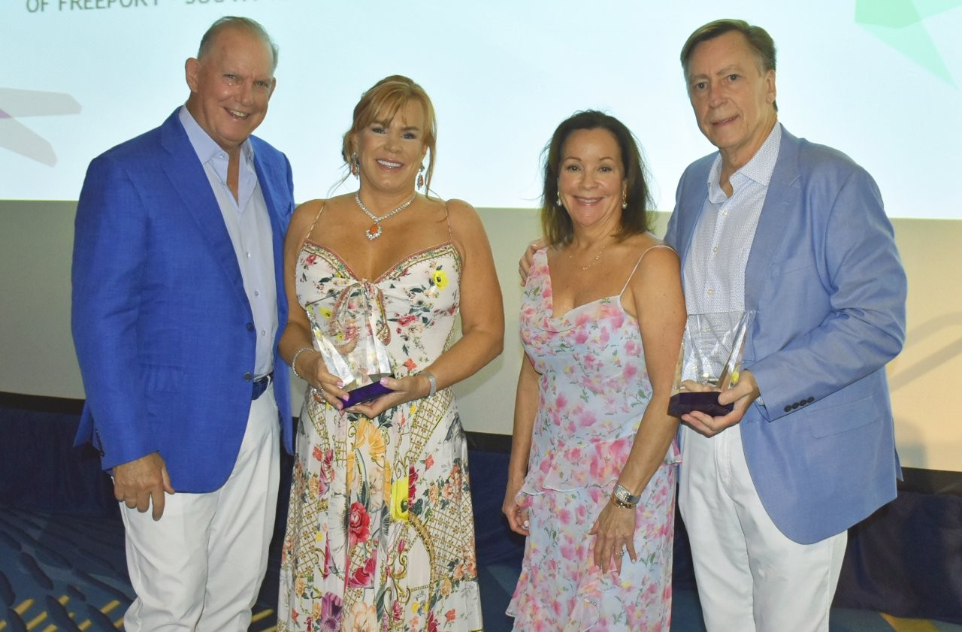

Jim and Tammy Pierce, along with Valerie and Mike Thompson, were recognized for their

philanthropic endeavors at the recent ECCAC Gala with the important Zeke Bratkowski Award.