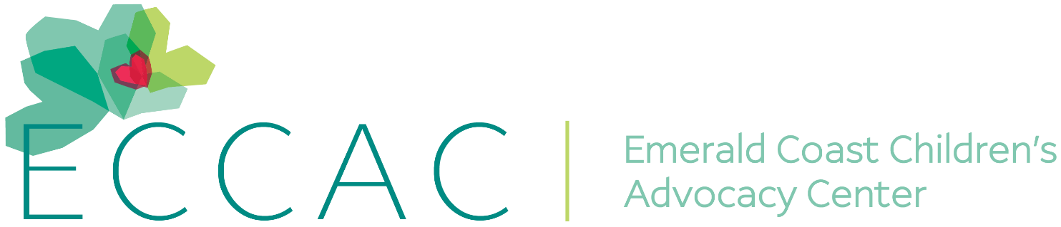
PR Contact:
Kay Phelan
Phelan & Lowry, Ltd.
850-376-1551
kayphelan@earthlink.net
FOR IMMEDIATE RELEASE

ECCAC benefits from Destin Charity Wine Auction Foundation donation

FL (September 21, 2025)…The Emerald Coast Children’s Advocacy Center (ECCAC) was one of 12 area charities who recently received a generous $225,000 donation from the Destin Charity Wine Auction Foundation (DCWAF).
“This will go a long way to help the children we serve at our three Centers,” commented ECCAC CEO, Julie Porterfield. “Over the past 20 years, we have received a significant $3.24 million in DCWAF donations that have enabled us to put so many important programs in place to provide services to the children at no cost. We are humbled and grateful to DCWAF for all they have done for children in Northwest Florida for 20 years now.”
One out of four children will be victimized in their lifetimes, but 95% of child abuse is preventable by education. ECCAC brings many organizations together in a child-friendly environment so the judicial and healing process can be easier for the children who are victims of abuse or neglect. In addition, ECCAC’s prevention initiatives have provided 17, 367+ students in Okaloosa and Walton County schools with their Child Safety Matters education programs. Across all of ECCAC’s programs, more than 25,000 children were served in 2024.

For more information, visit www.eccac.org. If abuse is suspected, report it by calling the anonymous Florida Abuse Hotline at 1-800-96-ABUSE.

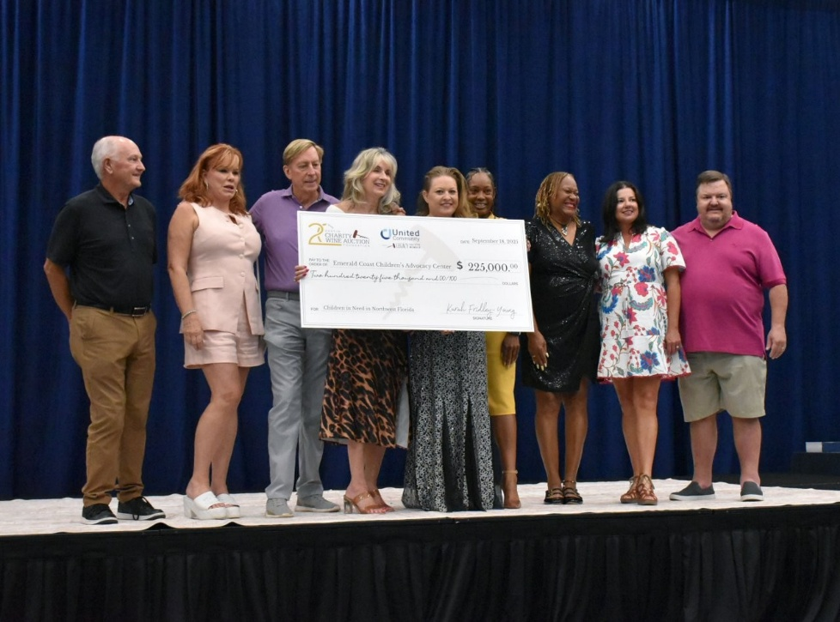
ECCAC Board members and staff received a significant $225,000
donation from DCWAF.

