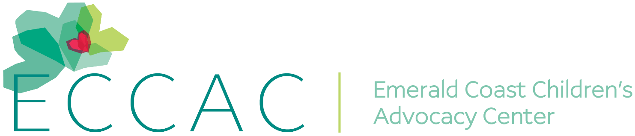
PR Contact:
Kay Phelan
Phelan & Lowry, Ltd.
850-376-1551
kayphelan@earthlink.net

FOR IMMEDIATE RELEASE

Harley Davidson Owners Group #3605 hosts annual
Toys 4 Tots Ride on the Emerald Coast to benefit kids in need

Ft. Walton Beach, FL (October 8, 2025)…Rev up your engines for a cause, the holiday season is just around the corner. The Emerald Coast Harley Davidson Owner’s Group # 3605 are proudly hosting their 46th annual Toys 4 Tots Ride and event on Sunday, November 16. As in years past, children at the Emerald Coast Children’s Advocacy Center (ECCAC) and Children In Crisis, Inc. (CIC) will benefit with toys collected and money donations.

This year, there will be a Pre-Registration Bike Night & Kick-off Party on Friday, November 14, from 6 to 9 pm at Emerald Coast Harley Davidson, 788 Beal Parkway NW, in Ft. Walton Beach, Visit their website at www.emeraldcoasthd.com.

Or, register the day of the ride on November 16, at 8:30am at Emerald Coast Harley Davidson. Bring $10 registration fee per person, along with a new toy or gift card to donate, and at 11 am, ride over to the Mullett Festival grounds. Enjoy an afternoon of fun with bike games, a best-decorated bike/auto contest, a truck show, a 50/50 drawing, DJ Anthony, delicious food trucks, and over 100 prizes.

ECCAC’s mission is to heal and prevent the trauma of childhood abuse and neglect by providing advocacy, child-friendly therapies, and a safe environment for kids to feel seen, heard, and understood. Though ECCAC doesn’t house children, they provide services to children and their families at no cost in their Okaloosa and Walton County centers. However, Children in Crisis does provide shelter in a nurturing environment in Ft. Walton Beach with foster homes, and transitional living programs for children who have been removed from their homes.

For further information, visit www.ECCAC.org/event or contact Kate McDougall at kate@ECCAC.org.

Page Two
Toys 4 Tots Ride

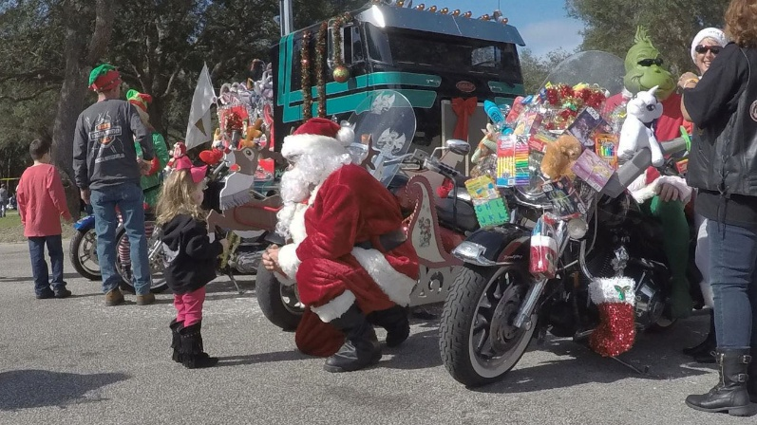
The 46th Annual Toys 4 Tots motorcycle ride presented by Emerald Coast
Harley-Davidson, and hosted by ECHOG #3605 from Ft. Walton Beach to
Niceville’s Mullet Festival site will be on Sunday, November 17.

