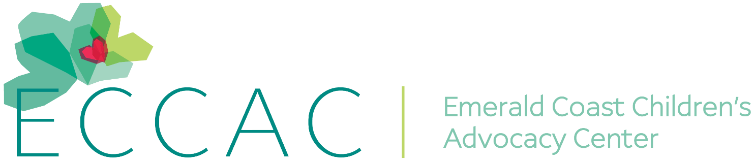
PR Contact:
Kay Phelan
Phelan & Lowry, Ltd.
850-376-1551
kayphelan@earthlink.net

FOR IMMEDIATE RELEASE

Holiday toy and gift requests by ECCAC for children in need

Niceville & DeFuniak Springs FL (November 7, 2025)…With the holiday season just around the corner, the Emerald Coast Children’s Advocacy Center (ECCAC) is putting out a call for help from the community and businesses to deliver unwrapped toys and gifts to stock ECCAC’s Toy Rooms for area children in need, from ages newborn to 18.
With two ECCAC Centers, the Julie Sacco Porterfield Family Center in Niceville and the Pierce Family Center in DeFuniak Springs, toys and gifts are being collected from now up until December 22nd. However, they would like to have items delivered to either Center prior to December 3rd so that effective December 5th, they can start handing out the toys and gifts to children in need. ECCAC will have Toy Rooms at each of their centers for not only ECCAC families to shop, but also their agency partners.

Julie Porterfield, ECCAC CEO, commented: “We love this time of the year when we can bring joy to our families and their children. Please help us stock our Toy Rooms so we can make the season brighter for those in need.”

Toys and gifts can be purchased and delivered directly from ECCAC’s Amazon wish lists with the click of a button. Or, shopping can be done locally and dropped off at one of the Centers. Visit www.eccac.org website under the Events section for a complete listing of items needed, broken down by age groups. Contact Sabrina@eccac.org to schedule a drop-off at either Center.

ECCAC’s mission is to prevent child abuse and neglect, protect children in Okaloosa and Walton Counties, and restore the lives and futures of these impacted children. Their child-friendly facilities house their agency partners to include a multidisciplinary team of child protection personnel, prosecutors, law enforcement, DCF, therapists, and ECCAC staff and volunteers. Services are provided at no cost by ECCAC, a 501-C-3 non-profit organization.

For more information, visit www.eccac.org, If abuse is suspected, report it by calling the anonymous Florida Abuse Hotline at 1-800-96-ABUSE.
# # #

Page Two
ECCAC Toy Room Drive

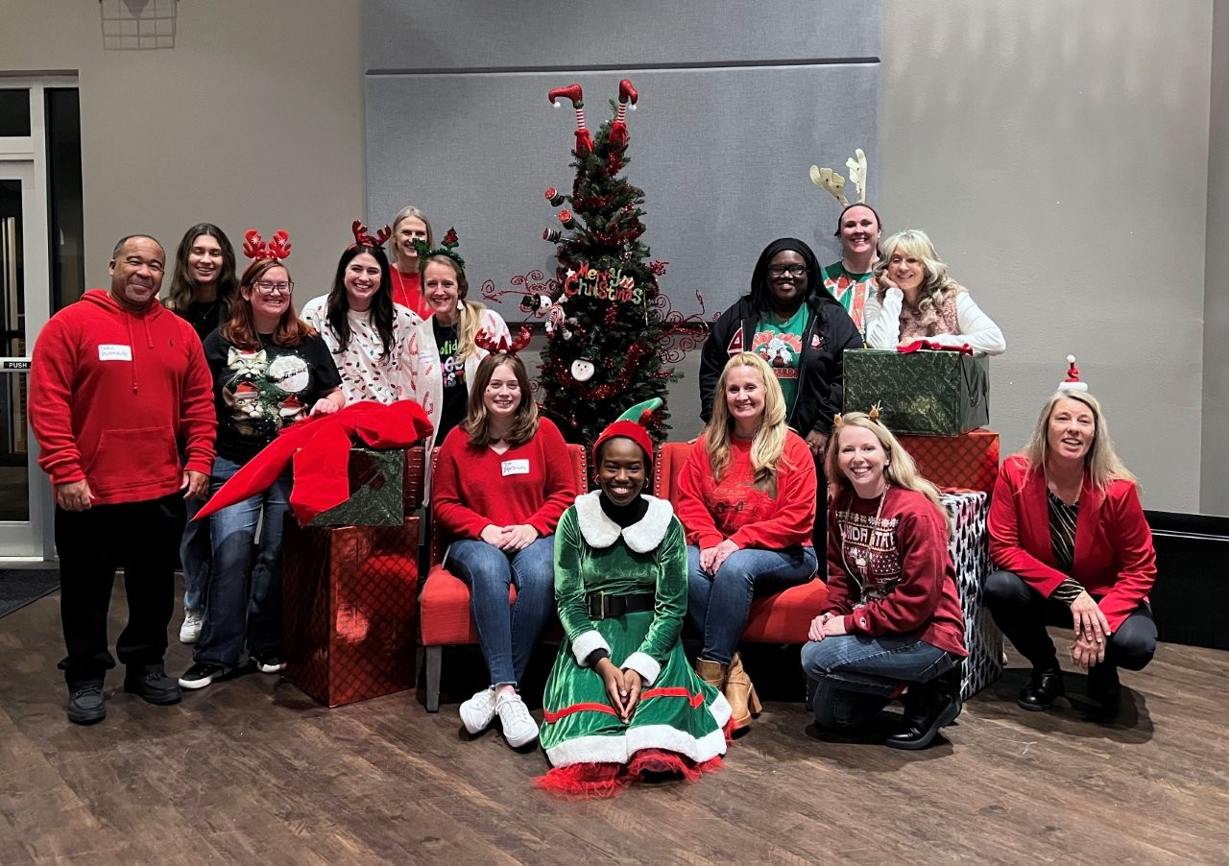
To benefit children in need, ECCAC staff kicks off this year’s annual Holiday season drive for toys and gift donations to stock their Toy Rooms in Okaloosa and Walton Counties.

