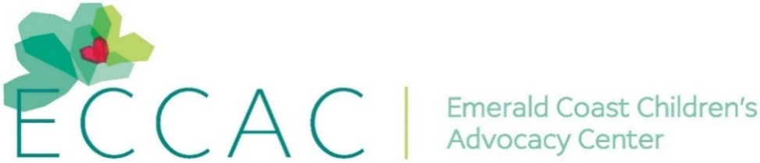
PR Contact:
Kay Phelan
Phelan & Lowry, Ltd.
850-376-1551
kayphelan@earthlink.net
FOR IMMEDIATE RELEASE

ECCAC receives holiday donations from Caduceus Society
Niceville and DeFuniak Springs FL (November 19, 2025)…At a recent gathering of the Caduceus Society on the Emerald Coast, the Emerald Coast Children’s Advocacy Center (ECCAC) graciously received $2,015 in gift cards and funds. Over the past 5+ years, the Caduceus Society has donated over $15,000 in gift cards and funds to support ECCAC’s Christmas efforts. ECCAC gives these gift cards and funds to area children and families in need for the holidays.
The Caduceus Society on the Emerald Coast of Florida is a philanthropic, physician-organized faith-based organization that is comprised of medical professionals in good standing. Their membership includes currently working or retired people who are committed to bringing medical care to the poor, the vulnerable, and the underserved through free health clinics, donation of time or financially. In addition, the Caduceus Society is active in generously supporting local charities, health clinics, purchasing medical equipment and providing grants for physician medical missions.
Lisa Wainwright, Caduceus Society Liaison and Development Specialist for Sacred Heart Foundation, commented, “ECCAC is such an important local charity providing many services to help heal children dealing with the trauma of childhood abuse and neglect. I am very proud of how our Caduceus Society members play such an important role helping so many in need throughout Northwest Florida.”
“We so appreciate the important role the Caduceus Society has played to help us each year with our Christmas giving programs to area children and families in need,” said ECCAC’s CEO, Julie Porterfield.
Though ECCAC does not house children, they provide services to children and their families at no cost in their Okaloosa and Walton County centers. Working together with their agency partners, generous donors, dedicated volunteers, and a caring community, over the past 25 years, ECCAC has helped more than 33,000 children.

For more information, visit www.eccac.org, If abuse is suspected, report it by calling the anonymous Florida Abuse Hotline at 1-800-96-ABUSE.

Page 2
ECCAC – Caduceus Society of the Emerald Coast

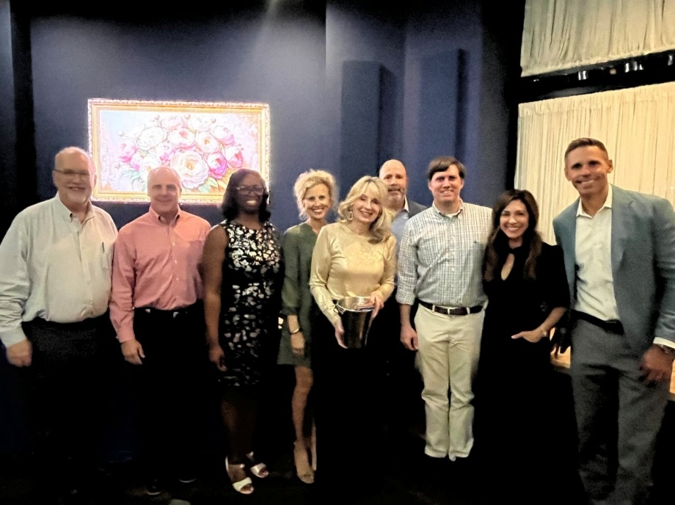
A partial membership showing of the Caduceus Society on the Emerald Coast recently presented
ECCAC CEO Julie Porterfield (center)with holiday gift cards and funds for children in need.

L-R…Dr. Jim Stevens, Dr. Warren Amos, Dr. Kerrian Hazley, Katherine McWilliams,
Julie Porterfield, Dr. Sean McWilliams, Dr. Nick Papajohn and Trey Abshier.

